Countable Noun

🔹 What is Countable Noun
# Source: AI Source: Provided by: [Data Path: Persons Table -> ID Column: 1, Name_En Column: Motasem Essam] -> From: [Chatgpt (GPT-4-turbo)] on [7/26/2025]
A countable noun is a noun that refers to things you can count individually.
✨ They have singular and plural forms (one apple, two apples), and can be used with numbers.

✅ Definition:
# Source: AI Source: Provided by: [Data Path: Persons Table -> ID Column: 1, Name_En Column: Motasem Essam] -> From: [Chatgpt (GPT-4-turbo)] on [7/26/2025]
Countable nouns are things, people, or places that can be counted as separate units.

🧮 Examples of Countable Nouns:
# Source: AI Source: Provided by: [Data Path: Persons Table -> ID Column: 1, Name_En Column: Motasem Essam] -> From: [Chatgpt (GPT-4-turbo)] on [7/26/2025]
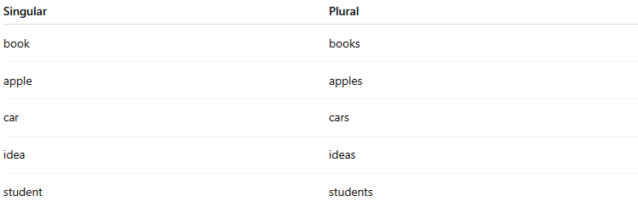
Singular | Plural
book | books
apple | apples
car | cars
idea | ideas
student | students

📝 Example Sentences:
# Source: Chatbot (GPT-4-turbo) at [7/26/2025]
- I have two pens in my bag.
- She bought three apples.
- There is a cat on the roof.
- We met five teachers today.

🧠 Common Features:
# Source: AI Source: Provided by: [Data Path: Persons Table -> ID Column: 1, Name_En Column: Motasem Essam] -> From: [Chatgpt (GPT-4-turbo)] on [7/26/2025]
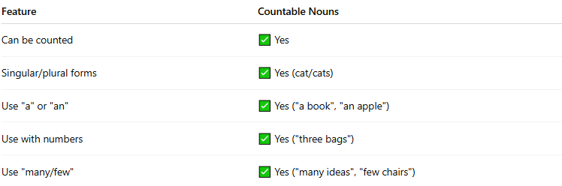
Feature | Countable Nouns
Can be counted | ✅ Yes
Singular/plural forms | ✅ Yes (cat/cats)
Use "a" or "an" | ✅ Yes ("a book", "an apple")
Use with numbers | ✅ Yes ("three bags")
Use "many/few" | ✅ Yes ("many ideas", "few chairs")

🔄 Opposite: Uncountable Nouns
# Source: AI Source: Provided by: [Data Path: Persons Table -> ID Column: 1, Name_En Column: Motasem Essam] -> From: [Chatgpt (GPT-4-turbo)] on [7/26/2025]
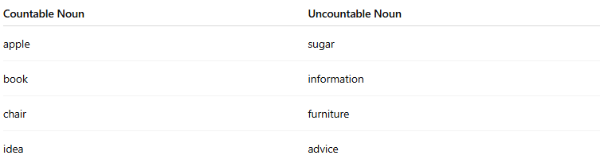
Countable Noun | Uncountable Noun
apple | sugar
book | information
chair | furniture
idea | advice

✅ Summary:
# Source: AI Source: Provided by: [Data Path: Persons Table -> ID Column: 1, Name_En Column: Motasem Essam] -> From: [Chatgpt (GPT-4-turbo)] on [7/26/2025]
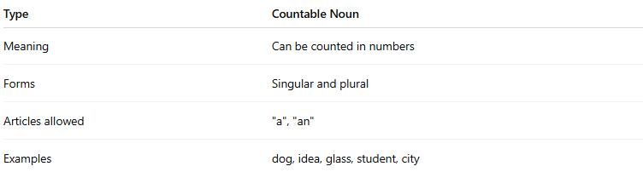
Type | Countable Noun
Meaning | Can be counted in numbers
Forms | Singular and plural
Articles allowed | "a", "an"
Examples | dog, idea, glass, student, city

